April 26 – Bug Docu/Not working functionalities

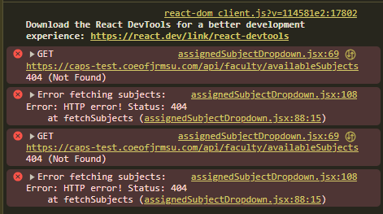
Can’t View and Assign Available Subjects

ERROR TEXT:
assignedSubjectDropdown.jsx:69 GET https://caps-test.coeofjrmsu.com/api/faculty/availableSubjects 404 (Not Found)
assignedSubjectDropdown.jsx:108 Error fetching subjects: Error: HTTP error! Status: 404 at fetchSubjects (assignedSubjectDropdown.jsx:88:15)
assignedSubjectDropdown.jsx:69 GET https://caps-test.coeofjrmsu.com/api/faculty/availableSubjects 404 (Not Found)
assignedSubjectDropdown.jsx:108 Error fetching subjects: Error: HTTP error! Status: 404 at fetchSubjects (assignedSubjectDropdown.jsx:88:15)
﻿

